August 25, 2014 | Adipose Stem Cells

Pilot Study of Adipose Stem Cells in the Treatment of Urinary Incontinence
Review of “Autologous Adipose Stem Cells in Treatment of Female Stress Urinary Incontinence: Results of a Pilot Study” from Stem Cells TM by Stuart P. Atkinson.
Stress- (SUI) and mixed (MUI) urinary incontinence are common problems in females, mediated through dysfunction of the urethral continence control system, which comprises the sphincteric unit and the vaginal support system. Some surgical treatments, such as mid-urethral slings, have good short and long term success rates [1], although some patients are not suitable for or do not wish such a treatment. An alternative therapy, as studied by the group of Kirsi Kuismanen from Tampere University Hospital, Finland, is the transurethral injection of easily obtainable mesenchymal-like stem cells from adipose tissue (ASCs) in order to regenerate sphincter muscle. They now report their findings of their pilot study in Stem Cells TM, finding this strategy to be safe, well-tolerated and effective in some patients [2].
The group used subcutaneous fat collected from the lower abdomens of patients with a diagnosis of either pure SUI or predominantly stress MUI, to isolate and grow ASCs grown using autologous serum [3, 4]. These displayed high cell viability, and expressed adhesion molecules (CD49d, CD73, and CD105), extracellular matrix protein CD90, and MHC class I isotype HLA-ABC, with little or no cells of hematopoietic and angiogenic lineages. Differentiation analysis found ASCs to be multipotent (see figure); adipogenic differentiation (AD - Oil Red O), osteogenic differentiation (OD - alkaline phosphatase), chondrogenic differentiation (CD - Alcian blue), and myogenic differentiation (α-SMA, SM22-α, and MHCII) capabilities were all observed. The researchers then mixed ASCs with collagen for trans-urethral injection into 5 patients and followed up for 6 months to one year. With the exception of small hematomas, there were no adverse events from the adipose tissue collection and there were no major complications after the transurethral injections. Before the procedure, all patients gave a positive result for a cough test with a full bladder, but by 6 months two gave a negative result, while three gave a negative result at 1 year. Pad tests found improvements in 4 of the patients, with less volume of liquid lost onto a pad over a 24 hour period. The group did not however find changes in either urodynamic parameters or in urine residual volume in any of the patients. There was a subjective improvement in all five treated patients according to various validated questionnaires, although three patients did not indicate improvement on all of the questionnaires.
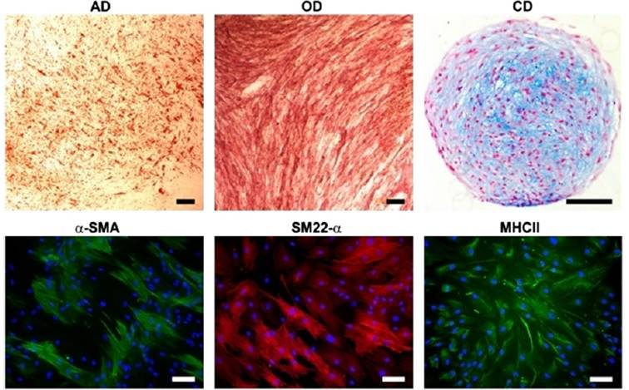
This small clinical study suggests that ASC injection is a viable treatment strategy for female urinary incontinence. Various other studies have investigated the use of primary myoblasts and fibroblasts, muscle-derived stem cells, and cord blood stems cells (see original study for extensive references) with some success. ASCs have the advantage of being easy to isolate and propagate, have been investigated as a potential method to treat male urinary incontinence [5], and furthermore, have been shown to improve SUI in rodent model systems [6-8]. Further investigations may assess the paracrine role of ASCs in improving sphincter muscle function, and increase the numbers of patients to further assess any positive clinical use of ASCs.
References
- Virkud A Management of stress urinary incontinence. Best Pract Res Clin Obstet Gynaecol 2011;25:205-216.
- Kuismanen K, Sartoneva R, Haimi S, et al. Autologous Adipose Stem Cells in Treatment of Female Stress Urinary Incontinence: Results of a Pilot Study. Stem Cells Transl Med 2014.
- Sandor GK, Tuovinen VJ, Wolff J, et al. Adipose stem cell tissue-engineered construct used to treat large anterior mandibular defect: a case report and review of the clinical application of good manufacturing practice-level adipose stem cells for bone regeneration. J Oral Maxillofac Surg 2013;71:938-950.
- Mesimaki K, Lindroos B, Tornwall J, et al. Novel maxillary reconstruction with ectopic bone formation by GMP adipose stem cells. Int J Oral Maxillofac Surg 2009;38:201-209.
- Yamamoto T, Gotoh M, Kato M, et al. Periurethral injection of autologous adipose-derived regenerative cells for the treatment of male stress urinary incontinence: Report of three initial cases. Int J Urol 2012;19:652-659.
- Fu Q, Song XF, Liao GL, et al. Myoblasts differentiated from adipose-derived stem cells to treat stress urinary incontinence. Urology 2010;75:718-723.
- Lin G, Wang G, Banie L, et al. Treatment of stress urinary incontinence with adipose tissue-derived stem cells. Cytotherapy 2010;12:88-95.
- Wu G, Song Y, Zheng X, et al. Adipose-derived stromal cell transplantation for treatment of stress urinary incontinence. Tissue Cell 2011;43:246-253.

